Date: 14-01-2023
By: Paulius Zabinskas
Student ID: 20120267

- Analysis and Design Notes
The goal is to design a Java programme that would:
- Ask the user to choose would they like to continue the programme chcking aplhabet forwards or backwards.
- Depending on users input in point(1). Direction of the game will be triggered.
- When the programme starts, start the timer, ask user to put in the first letter, check if the letter is correct using array indexing. If the input is correct, continue with the next letter, if incorrect, ignore the input.
- The programme will take in capital cases too, but conversion will occur to lower case.
- When the last letter is entered, stop the timer, display time.

- Problem Statement
- I had an issue handeling the array in an elegant maner. When last index is reached the the loop will try to access -1 index or index out of bounds (26) to display next letter to type for the user. To solve this I used try&catch method. This error was unexpected. other

- Code:
import java.util.ArrayList;
import java.util.Arrays;
import java.util.List;
import java.util.Scanner;

public class Assignment_1 {

List<String> arrayList = new ArrayList<>(Arrays.asList("a", "b", "c", "d", "e", "f", "g", "h", "i", "j", "k", "l",
"m", "n", "o", "p", "q", "r", "s", "t", "u", "v", "w", "x", "y", "z"));

protected static Scanner sc = new Scanner(System.in);

public static void main(String[] args) {

Assignment_1 g = new Assignment_1();
g.game();
}

public void game() {
System.out.println("\n\n\t===== Type alphabet in order. (Game)======");
System.out.println("\tTime will start when u choose game direction");
System.out.println("\tChoose to play the game forwards or backwards (f/b)");
boolean forwards = (f_or_b()); // return boolean
final long startTime = System.currentTimeMillis();
testGame(forwards);
final long endTime = System.currentTimeMillis();
System.out.println("Total execution time: " + (endTime - startTime) + " ms");
System.out.println("Total execution time: " + (endTime - startTime) / 1000 + " seconds");

}

public boolean f_or_b() {
String letter = "";
while (!letter.equals("f") || !letter.equals("b")) {

letter = sc.nextLine().toLowerCase();
if (letter.equals("f")) {
System.out.println("\t You have chosen to play the game forwards");
break;
}
if (letter.equals("b")) {
System.out.println("\t You have chosen to play the game backwards");
break;
} else {
System.out.println("Not valid input. Choose 'f' or 'b' to start.");
}
}
return letter.equals("f") ? true : false;
}

public void testGame(boolean direction) {

System.out.println("\t");
if (direction) {
System.out.println("To start type 'a'");
int i = 0;
while (arrayList.size() - 1 >= i) {
String l = sc.nextLine().toLowerCase();
if (l.equals(arrayList.get(i))) {
try {
System.out.println(l + ": Correct! Now type " + arrayList.get(i + 1));
i++;
} catch (Exception e) {
if (l.equals("z")) {
System.out.println("Done");
break;
} else {
;
}
}
} else {
;
}
}
} else {
System.out.println("To start type 'z'");
int i = arrayList.size() - 1;
// i = 1;
while (0 <= i) {

String l = sc.nextLine().toLowerCase();
if (l.equals(arrayList.get(i))) {
try {
System.out.println(l + ": Correct! Now type " + arrayList.get(i - 1));
if (i > 0) {
i--;
}
} catch (Exception e) {
if (l.equals("a")) {
System.out.println("Done");
break;
} else {
;
}

}

} else {
;
}

}
}

}

}

- Testing:
Test_1:
Testing_1.1: backward and forward options works in an itended way, to take in only ‘f’ or ‘b’.
Testing_1.2: when game method is trigered, display first letter, if the letter is typed, display the next letter and itterate to next index value. othervise, ignore any other input.
Testing_1.3: to make code more robust, make sure that capital cases can be read as valid value.

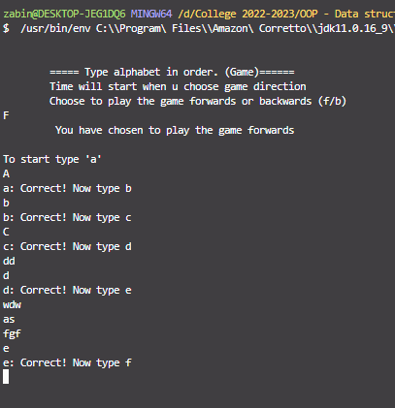

Test_2:
Testting if forward & backward derections work as intended.
